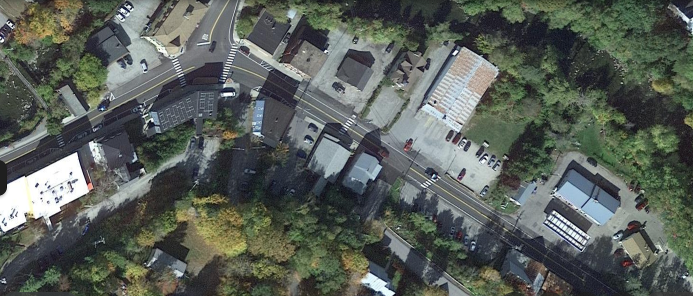
Village Laundromat
Hardwick Mill & South Main Streets Scoping Study

Aerial view of project area showing several key businesses, and examples of insufficient pedestrian infrastructure.

End of sidewalk, northeast side of street
Non-compliant crosswalk
Non-compliant (now missing) crosswalk
Challenging intersection
Missing or substandard sidewalk

Public Parking Lot
Mill Street
South Main Street
Pedestrian Bridge
Buffalo
Mtn. Market
US Post
Office
Rural Arts Collaborative

